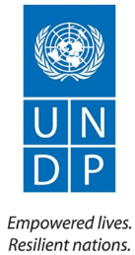
Access to Justice and Rule of Law Project
Project Number: 00077970
2019 Annual Report
March 2020

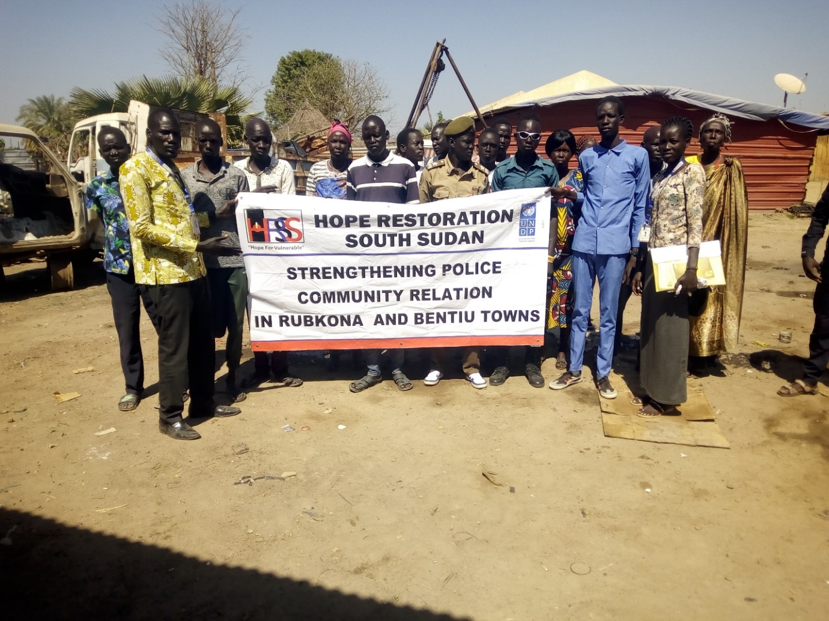

Access to Justice and Rule of Law Project in collaboration with Hope Restoration awareness and community sensitization to strengthen police and community relations in Bentiu. November 2019. (Photo UNDP)

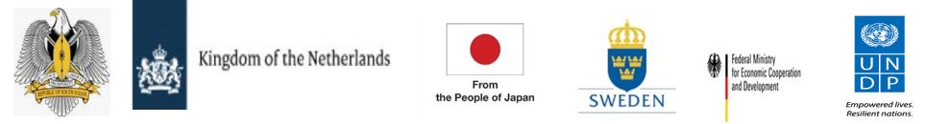

Project Summary | Country: South Sudan  Project Duration: October 2017 – March 2020  Project Budget: US$: 45,683,422.00  Annual Budget: US$ 7,743,186.41  Donor Budget in USD Cumulative Expenditures  Netherlands 5,150,807.21 4,862,841.27  PBF 78,281.88 55,761.04  UNDP 767,073.00 585,044.59  JAPAN 527,870.91 325,642.48  Germany 67,179.23 61,985.94  Sweden 445,946.18 439,448.56  UN Action against sexual violence 706,028.00 498,575.64  TOTAL 7,743,186.41 6,829,299.52  Cumulative expenditure: US$ 6,829,299.52  Contact Persons:  Kamil Kamaluddeen, PhD  Resident Representative  Tel. +211 920 694 101  kamil.kamaluddeen@undp.org  Evelyn Edroma  Chief Technical Advisor  Tel. +211 920580240  evelyn.edroma@undp.org
Responsible Parties: Ministry of Justice and Constitutional Affairs, Judiciary of South Sudan, South Sudan National Police Service, National Prisons Service of South Sudan, collaborating UN Agencies, and Civil Society Organizations.

Table of Contents.
Acronyms 1
Executive Summary 2
1. Siuatunal Background…………………………………………………………………………………………………………..7
2. Progress towards development results 8
2.1 Contribution to Longer Term Results 8
2.2. Progress Towards Project Outputs 8
2.3 Human Interest Story. 16
3. Cross Cutting Issues 16
3.1 Gender Results 16
3.2. Partnerships 17
3.3. Environmental Considerations 18
3.4. Sustainability 18
3.5. South to South and Triangular Cooperation (max 1/2 page) 18
3.6. Strengthening National Capacity 18
4 Monitoring and evaluation 20
5 Risk Management 24
6 Challenges 24
7 Lessons Learned: 25
9. Financial Summary 27

Acronyms

Acronyms

AWP | Annual Work Plan
R-ARCSS | Revitalized Agreement on the Resolution of Conflict in the Republic of South Sudan
CMS | Case Management System
CPD | Country Programme Document
CSO | Civil Society Organizations
ECC | Emergency Call Center
JoSS | Judiciary of South Sudan
MoJCA | Ministry of Justice and Constitutional Affairs
NPSSS | National Prisons Services of South Sudan
PCRC | Police Community Relations Committee
SGBV | Sexual and Gender-Based Violence
SPU | Special Protection Units
SSNPS | South Sudan National Police Service
ToT | Training of Trainers
UNDP | United Nations Development Programme
UNFPA | United Nations Population Fund
UNPOL | United Nations Police
UNMISS | United Nations Mission in South Sudan
VTC | Vocational Training Centre

Executive Summary

The Access to Justice and Rule of Law Project aims to strengthen the rule of law in South Sudan by supporting rule of law institutions to maintain law and order, enhancing equitable access to justice by the public, strengthening the criminal justice system, increasing security in communities, and promoting and protecting human rights for all. The project contributes to Country Programme Document (CPD) outcome 1 “Strengthened peace infrastructures and accountable governance at the national, state and local levels.’’

The project adopts a sector-wide approach, by strengthening the supply and demand sides of justice services through support to relevant initiatives guided by international human rights standards and principles by focusing on three inter-related outputs; i) Functions and capacity of rule of law institutions enabled to deliver accountable, effective and equitable justice services; ii) Measures in place and implemented in the rule of law sector to prevent and respond to sexual and gender-based violence; and iii) Human rights and transitional justice mechanisms strengthened to monitor and respond to the promotion and protection of citizen's rights.

Under the Global Focal Point for Police, Justice, and Corrections (GFP), UNDP brings together key actors, the United Nations Mission in South Sudan (UNMISS)- Rule of Law Advisory Section, United Nations Police (UNPOL), Human Rights Division; and United Nations Population Fund (UNFPA) to coordinate and achieve the objectives and the anticipated results.

Main achievements during the year

- Enhanced police responsiveness through the Emergency Call Centers (ECCs) in Juba: The Juba Emergency Call Center (ECC) responded to 8,943 calls via the 24 hours a day 7 days a week toll-free number that enables citizens to contact police across all mobile communications networks. The calls made to the ECC include medical emergencies, traffic accidents, theft and GBV cases. Upgrades to the Wau ECC which included relocation to a new site and restoration of all the channels of communication between the police divisions and sectors were completed. In preparation to operationalize the Wau ECC, 105 (27 female) police personnel were trained and provided with the necessary skills and equipment to respond to emergency calls at the ECC.
- Strengthened engagement between Rule of Law institutions by facilitating 45 rule of law forums attended by 1,050(314female) in six states including Juba, Bor, Aweil, Wau, Torit and Yambio. Participants in the rule of law forums included representatives of the rule of law and justice actors including Judiciary of South Sudan (JoSS), Ministry of Justice and Constitutional Affairs (MoJCA), National Prisons Service of South Sudan (NPSSS), South Sudan National Police Service (SSNPS), community leaders and traditional leaders. Other participants include UN agencies, UNMISS, UNPOL, NGOs and CSOs. The forums provide a platform for the rule of law, justice and law enforcement actors to address issues of concern in their respective institutions. Some of the issues resolved through the Rule of law forums have included arbitrary detentions, arrest and detention of minors and advocacy and commitments from partners to maintain prison facilities.
Improved professional capacity of the South Sudan National Police Service; One thousand, one hundred and three (1,103<258 female>) police officers in senior and mid-level management, rank file had their professional capacities improved. The officers received on-the-job training, mentoring and coaching on effective investigation, compliance with human rights and fair trial standards, maintenance of law and order, and responsiveness to gender-based violence and conﬂict related sexual violence. Through a specialized Training of Trainers(ToT), the project also trained 105(24female) civil servants drawn from the South Sudan National Police Service (SSNPS) and National Prisons Service of South Sudan (NPSSS) on data collection and analysis of crimes and inmates’ statistics. The Training of Trainers (ToT) training capacitated the police and prison officers with standardized data collection tools and analysis skills to process crime statistics from the payam to the national level. The project also improved the knowledge and capacity of 25(5 female) Forensic Investigation Officers through a one-month training where the participants were equipped with basic knowledge of Forensic Sciences (Forensic Pathology, DNA Analysis and Typing, Forensic Toxicology, Crime Scene Management etc.), the officers were provided with necessary and basic knowledge that qualified them to join the Forensic Investigator team of the police officers in the country.
- Improved prison infrastructure and provided skills training for inmates. Three prisons were renovated in Yei, Terekeka, Malakal and basic amenities were provided for improving the standards of living and human rights of inmates. The project also continued to provide vocational skills training in Juba where 153 convicted inmates graduated with skills training in 12 fields including tailoring, masonry, bakery, ICT, welding, among others. The project also completed the construction of the Wau Vocational Training Center where skills training has begun. A total of 246 (9 female) inmates are currently enrolled in the Juba and Wau Vocational Training Centers. A total of 67 of the trained inmates have been released and reintegrated back to the society out of which 23 are now gainfully employed.

- Established and operationalized the first GBV and Juvenile court in South Sudan to strengthen response to Sexual and Gender-based Violence (SGBV)and expedite trial. The project renovated the court building, provided equipment, developed the training manual on the investigation and prosecution of SGBV cases, trained 87 justice actors including judges, prosecutors, investigators and social workers. Twenty-one (21) justice actors have been deployed to the court. the Special SGBV court. This sends a strong signal to end impunity against SGBV cases and will enable survivors to obtain on-time redress and fair remedies for their grievances as well as end impunity and hold perpetrators accountable for their crimes. The project also established the Technical Working Group that will oversee the process of the drafting of the Anti GBV bill in partnership with UNFPA.

- Reduced 74% of the annual recorded case backlog and prison overcrowding. through deployment of five mobile courts to Yambio, Rumbek, Ruweng and Terekeka. The mobile courts resolved 291 cases out of 386 listed backlogged cases with 166 convictions, 121 acquittals and 102 pending cases. Of the 386 cases resolved, 27 were GBV cases ruled in favor of women.

- Provided legal aid services to 1,928 (53% female) vulnerable people to address their justice needs through 4 newly established Justice and Confidence Centers in Bentiu, Wau, Bor and Malakal and 4 previously established ones.

- Improved Case Management Systems (CMS which link the Police, Ministry of Justice and Constitutional Aﬀairs, the Judiciary and Prisons and make it possible to track cases. A total of 13,725 cases were captured through the CMS, 1,679 cases were disposed, 4,710 cases are partly heard, and 7,326 cases are still under investigation. Plans are underway to upgrade the existing manual CMS to an automated system and in this regard 74 (12 female) personnel drawn from police, prisons, justice and the judiciary from the10 former states were trained on elements of case management including data collection, entry, analysis and reporting and provided with office equipment.

- Improved local-level security and increased public trust in law enforcement in 9 states. This was achieved through 27 community-level policing initiatives and Police and Community Relations Committee meetings (PCRCs). A total of 41 new PCRCs were established following community demands in response to high crime rates and violence, and 81 previously established PCRCs remained operational. A total of 10,368(5,364 female) participated in these meetings. The PCRCs provide oversight to community watch groups by coordinating night patrols and providing a platform for police and members of the community to meet and discuss security-related issues. PCRCs have helped improve local-level security and enhanced police-community relations as they have increased community members’ confidence in formal justice and security systems.

- As part of UNDP’s support to the Revitalized Agreement for the Resolution of Conflict in South Sudan (R-ARCSS) 27 members of the transitional justice working group were trained on the legal framework to establish the Commission for Truth Reconciliation and Healing (CTRH) as provided for in Chapter V of the R-ARCSS. Further, 32 Police Commissioners and the Director-General for the Abyei Police Administrative area were trained on their roles regarding the implementation of the R-ARCSS guidelines on policing and protection services to citizens during the transition period. Ten thousand (10,000) copies of the agreement were also printed and distributed in Juba, Bor, Aweil, Wau, Torit and Yambio to Government offices to sensitize them on the contents of the R-ARCSS.

- The project also contributed to the development of the Strategic Action Plan on Conflict Related Sexual Violence (CRSV) for South Sudan People Defence Forces ( SSPDF), SSNPS and (South Sudan people Liberation Movement- in Opposition(SPLM-IO, with the objective of providing a holistic roadmap for the prevention and response to CRSV in South Sudan during an initial period of three years (October 2019 – September 2022). The Action plans intends to eradicate the commission of CRSV by SSPDF, SSNPS and SPLM-IO , as well as to make a significant contribution to the fight against sexual violence in the country in general, including the fight against impunity and the protection of survivors and witnesses.
- Reviewed five security laws: A package of ﬁve security laws including the Police Service Act 2009, SPLA Act 2009 (now SSDPF), National Security Service Act 2014, Prisons Service Act 2011 and Wildlife service Act 2011 were reviewed in line with institutional reforms provided for in the R-ARCSS. It is foreseen that the laws will be enacted in 2020. The project also ensured women’s participation in formulating the Land Policy by collecting views from women representatives drawn from the 32 states in regard to land access, ownership and inheritance rights to inform policy. The recommendations have been passed to the Head of Land Committee in the Transitional National Legislative Assembly and the Ministry of Gender, Child and Social Welfare for inclusion in the Land Policy.
- Improved operational capacity of key justice sectors including the South Sudan National Police Service (SSNPS); the newly renovated and improved Dr. John Garang Police Training Academy in Rajaf. The academy includes seven (7) dormitories for men cadets, four (4) dormitories for female cadets, five (5) dormitories for forensic officers, six (6) washrooms, seven (7) five-stance VIP latrines, three (3) dining halls and storage facilities, and a water supply system. In collaboration with the UNDP Office of Information Management and Technology Green Energy Solutions, the training academy was equipped with renewable solar power infrastructure.
- Inculcation of a culture of strategic planning in the Police and Bar Association: UNDP provided technical support for the development of two strategic documents i.e. SSNPS Strategic Plan 2019 -2024 and the South Sudan Bar Association Strategic Plan 2019-2023 through participatory processes. The Police plan being disseminated in the 32 States, seeks to strengthen its governance system, increase public conﬁdence in the police, expand capacity building using a gender lens, improve conditions of services and welfare of the police and systematically respond to conﬂict related sexual violence. Three hundred copies of the Bar Association strategic plan have also been shared among its members to involve them in reforms without which private lawyers will continue to delay justice.

Challenges faced during the implementation period;

During the reporting period, the project faced several challenges that slowed the pace of implementation of activities at both the national and sub-national levels as follows:

- Inadequate human and material capacity for rule of law institutions continues to impact on the quality of services provided by the government. Limited technical skills and budgetary constraints of partner institutions negatively impact on their ability to address technical issues. UNDP continues to provide technical support and coaching to government and civil society partners.

- The effects of the conflict have created a complex situation with high unmet justice and security needs among the vulnerable groups. This over-stretches the capacity of UNDP and its partners to implement project activities. The densely populated Protection of Civilians sites and the new wave of returnees from Sudan to Bentiu state has created an immense pressure on national partners to deliver on law enforcement activities within and outside the Protection of Civilians in various states. The project responded to this by intensifying resource mobilization to diversify its donor base to meet the mounting demands.

Lesssons learnt:

- Partnerships with local CSOs stimulate the demand for effective justice delivery. A focus on capacity building of community-based organizations empowers people/organizations within their communities to respond to legal issues and engage with justice and related administrative systems more effectively.

- Implemented strategies should be revisited periodically to review efficiency and compatibility with international standards. The mobile court system, for example, requires laying down additional measures to ensure sustainability and national ownership. Furthermore, its effectiveness, responsiveness and respect to international human rights and fair standards should be ensured through constant monitoring.

- It is important to recognize that rule of law sector capacity development is a long-term endeavour requiring a sector-wide approach in project implementation. Partnerships at the local, state and national levels are crucial to contribute to improved access to justice. This has informed UNDP’s approach in the Access to Justice and Rule of Law project.

- Importance of collaborating with UN agencies: Many opportunities were presented for UNDP to collaborate with other UN agencies. In this regard the project forged partnerships with UNFPA and UNICEF in conducing SGBV and community policing training. This collaboration reduced the cost of activity implementation and created sustainable mechanisms for collaborative training.

- Importance of continued engagement with national counterparts including the MoJCA, JoSS, Police and prisons: Continued engagement with national stakeholders facilitated the convening of forums and stimulated dialogue on sensitive political, rule of law, and peace and reconciliation issues, such as transitional justice, the R-ARCSS peace agreement, SGBV and other protection issues.

Budget
Provisional cumulative expenditure from January to December 2019 is US$ 6,829,299.52 representing a delivery of 88.197 percent of the annual budget US US$7,743,186.41).

1. Situation Background

South Sudan experienced two significant conflicts since its independence in 2011: the first in December 2013 and the second in July 2016. Whilst these conflicts are associated with political contestations, they more often degenerate into ethnic conflagrations resulting from longstanding ethnic tensions in the three regions of Greater Bahr el Ghazal, Greater Equatoria and Greater Upper Nile. Consequently, the conflict has created a fragile environment for development.

The Revitalized Agreement on the Resolution of the Conflict in the Republic of South Sudan (R-ARCSS) signed on 12 September 2018 presents a new opportunity to build sustainable peace in the country. The urgency for this will heighten once the constitutional amendment incorporating the Peace Agreement into the Transitional Constitution is enacted as it places a legal obligation for the Revitalised Transitional Government of National Unity (R-TGoNU) to act.

The implementation of the agreement requires a professional and qualified civil service. In recognition of this, the Peace Agreement calls for the Revitalised Transitional Government of National Unity (R-TGoNU) to “restructure, rehabilitate and ensure reforms of the Judiciary and enhanced capacity of the South Sudan National Police Service (SSNPS).” In this regard, the project continues to support the rule of law institutions to facilitate the peace process within the broad context of justice reforms and related systems, so that they can address the root causes of past conflict and create an environment in which the poor and disadvantaged can have justice and security. Empowering the poor and disadvantaged to seek remedies for injustice, strengthening linkages between formal and informal structures, and countering biases inherent in both systems can provide access to justice for those who would otherwise be excluded.

The project aligns with the following development frameworks: South Sudan 2040 Vision and the National Development Strategy, which both prioritize peace, security, rule of law, justice, human rights and accountability.

In line with Goal 16 of Agenda 2030 and anchored in UNDP Strategic Plan (2018-2021) Signature Solution 2 - Strengthen effective, inclusive, and accountable governance; and United Nations Cooperation Framework outcome 1 and Country Programme Document, 2019-2021 -“Strengthened peace infrastructures and accountable governance at the national, state and local levels.” The project adopts a sector-wide approach, by strengthening the supply and demand sides of justice services by focusing on three inter-related outputs; i) Functions and capacity of rule of law institutions enabled to deliver accountable, effective and equitable justice services; ii) Measures in place and implemented in the rule of law sector to prevent and respond to sexual and gender-based violence; and iii) Human rights and transitional justice mechanisms strengthened to monitor and respond to the promotion and protection of citizen's rights.
To achieve these outputs, the project works closely with the government, other UN agencies, and Civil Society Organizations (CSOs). In this regard, the project deploys staff into the field to work closely with actors on the ground, including with the government at the highest levels to build legislative and regulatory capacity.

Progress towards development results

2.1 Contribution to Longer Term Results

Interim Cooperation Framework (ICF)/Country Programme Document (CPD) Outcome 1: “Strengthened peace infrastructures and accountable governance at the national, state and local levels.”

Summary achievements based on CPD Outcome One targets
CPD outcome targets | Summary achievement to date | Status
Four thousand GBV cases (50% women) reported to authorities receiving judgment in the formal justice system. (baseline 1,324 (58% women) | 517 (76 percent female).  Cumulative number: 1,841 (80 percent female). | Ongoing
Ten police and community relationship committees established and operational at community level. (baseline 5) | 36 new PCRCs have been established and are operational in 2019.  Cumulative number: 41. | Ongoing
Five thousand indigent persons (1,500 female, 3,500 male) provided with legal aid services, disaggregated by sex. (Baseline: 220 (68 female, 152 males. | 1,158 (591 female)  Cumulative number: 1,378 (591 female). | Ongoing
Two thousand SGBV survivors (800 females, 1200 males) benefitting from victim redress mechanisms, including on transitional justice. (Baseline: 125 (50 females, 75 males) | 650 (432 female)  Cumulative number: 775 (482 female). | ongoing
Overall status |  | Ongoing

Progress Towards Project Outputs

Project Output One: Functions and capacity of rule of law institutions enabled to deliver accountable, effective and equitable justice services.
Summary achievement against 2019 Annual Work Plan (AWP) target

Indicator | Annual Output Target (2019) | Summary achievement  (cumulative) | Status: “Fully, Partially, Not Achieved”
1.1 Number of legislative reviews informed by international standards and norms. | 4 | 6 laws were reviewd | Achieved
1.2 Number of backlogged cases resolved through the mobile court system, disaggregated by sex. | 400 | 291 backlogged cases were resolved | Partly achieved.
1.3 Proportion of trained inmates who indicate that they will have been adequately rehabilitated for reintegration in society when released | 31 percent | 100 percent of the 153 inmates who graduated from the Vocational Training Centre (VTC) in Juba indicated that they will have been adequately rehabilitated for reintegration in society when released.  Construction of the Wau VTC was completed and training on 12 trades began.  246 (9 female) inmates are currently enrolled in the Juba and Wau VTC. | Achieved
1.4 Number of cases disposed of through the case management system (CMS) | 6,500 | 1,679 cases were disposed through the CMS. 74 (12 female) personnel were also trained on automated case management system. | Ongoing
1.5 Number of traditional leaders trained on South Sudanese laws, international standards, and dispute resolution. | 60 | 249(69 female) traditional leaders received training on South Sudanese laws. | Achieved
 | Overall status |  | Achieved

Description of results.

Indicator 1.1: Number of legislative reviews informed by international standards and norms. (Baseline 4)

Under the leadership of the National Constitutional Amendment Committee, six (6) laws were reviewed in 2019 in line with institutional reforms provided by the R-ARCSS. These were the Police Service Act 2009, SPLA Act 2009 (now SSDPF), National Security Service Act 2014, Prisons Service Act 2011, Wildlife Service Act 2011 and the Land Policy.

In partnership with United Nations Food and Agriculture Organization (FAO) and International Organization for Migration (IOM), the project also supported the development of recommendations that address the challenges in accessing and ownership of land, that will be included in the Land Policy currently being developed. The consultative workshop held in Juba was attended by thirty-two women drawn from the 32 states of South Sudan including state Members of Parliament, members of the State Transitional Legislative Assemblies, States Ministries of Gender, Child and Social Welfare, women community leaders and other state ministers. Participants debated on the challenges that women face in relation to access and use of land including ownership and inheritance, and made recommendations that aim to address women's land rights. The recommendations have been conveyed to the Head of Land Committee in the Transitional National Legislative Assembly and the Ministry of Gender, Child and Social Welfare for further inclusion in the Land Policy document.

The project continues to monitor progress through the different government institutions for the five reviewed security laws as they are yet to be passed into law by the Transitional National Legislative Assembly (TNLA

Indicator 1.2 Number of backlogged cases resolved through the mobile court system, disaggregated by sex. (Baseline o)

Five mobile courts dispatched to Ruweng, Rumbek, Terekeka and Yambio resolved 291 cases out of 386 listed backlogged cases with 166 convictions, 121 acquittals and 102 pending cases. Of the 291 cases resolved, 27 were SGBV cases involving women. Mobile courts help reduce prison overcrowding and, in some locations, where there are no judges, they enable the citizens to access justice services. In a bid to improve functionality and operation of mobile courts and enhance sustainability, quality of mobile court decisions and adherence to international human rights standards, a round table consultative meeting was held engaging all the stakeholders including UNMISS, judges, prosecutors and defense lawyers.

Indicator 1.3: Proportion of trained inmates who indicate that they will have been adequately rehabilitated for reintegration in society when released. (Baseline 25/400)

All the trained inmates (153 inmates) who graduated from the VTC in Juba in 2019 indicated that they were adequately rehabilitated for reintegration in society when released.

The project also completed the construction of the Wau Vocational Training Centre (VTC) and training began across 12 trades. There are currently 246 (9 female) inmates enrolled in the Juba and Wau VTCs and they continue to receive training in different fields including tailoring, masonry, bakery, Information and communications technology (ICT), and welding, among others.
The project monitoring in 2019 revealed that the ongoing skills training had contributed to an improvement in the behaviour of the inmates, and most of them look forward to release and re-integration back into society, and employ the newly acquired skills. The total number of trained inmates since training began in the VTC is 697.

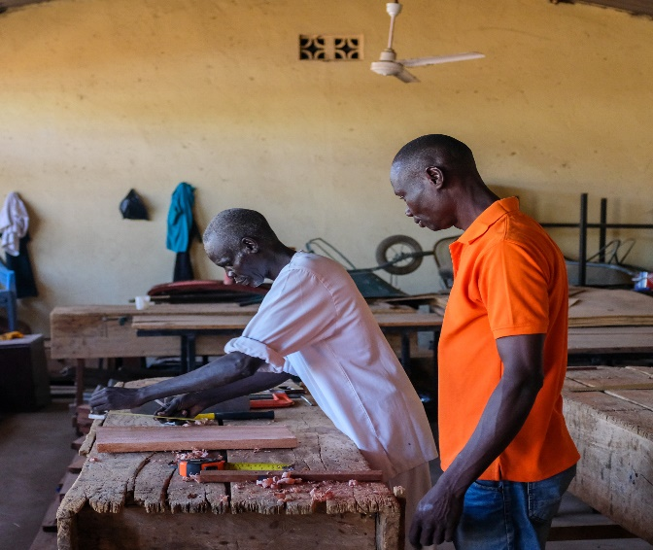  Figure 1: inmate being trained on carpentry at the Juba VTC in February 2019. Photo: UNDP | 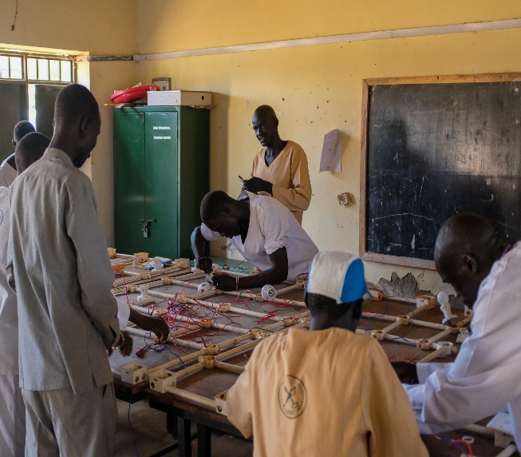  Figure 2: Inmates being trained on electrical installation at the Juba VTC in February 2019. Photo: UNDP.

Indicator 1.4: Number of cases disposed of through the Case Management System (CMS). (Baseline: 1,644)

One thousand, six hundred and seventy-nine (1,679) cases were disposed through the CMS from the 13,725 captured cases. Four thousand, seven hundred and ten (4,710) cases have been partly heard and seven thousand, three hundred and twenty-six (7,326) cases are still under investigation.

Plans are underway to upgrade the existing manual CMS to an automated system. In this regard, 74 (12 female) personnel drawn from police, prisons, justice and the judiciary were trained on elements of case management including data collection, entry, analysis and reporting. The personnel were drawn from different states including Central Equatoria, Warrap, Northern Bahr el Ghazal, Western Bahr el Ghazal, Western Equatoria, Lakes, Eastern Equatoria and Jonglei. Office equipment including computers, printers and Uninterruptible Power Supply (UPS) systems have also been provided to stakeholders at all branches of the justice chain (police, prisons, Justice and judiciary) to expedite and harmonize exchange of data.

Indicator 1.5: Number of traditional leaders trained on South Sudanese laws, international standards, and dispute resolution. (Baseline: 163 (45 female)

A total of 249 (69 female) traditional leaders have been trained on South Sudanese laws and principles of human rights in line with international standards, across 6 locations namely Bor, Yambio, Juba, Torit, Aweil and Wau. The post-training questionnaires indicate that the traditional leaders received an increased knowledge of human rights based on international standards. Project monitoring has revealed that the traditional leaders who have received the training on principles of human rights and South Sudan laws are upholding them. During project monitoring, the traditional leaders were observed to be making references to the various legal texts including the Penal Code Act of 2008 which have been provided by the project. The project continues to sensitize the traditional leaders on principles of human rights, SGBV and South Sudan Laws.

Project Output Two: Measures in place and implemented in the rule of law sector to prevent and respond to sexual and gender-based violence.

Summary achievement against 2019 AWP target
Indicators | Annual Output Target (2019) | Summary achievement  (cumulative) | Status:
2.1 Number of indigent persons accessing legal aid services | 5000 (50 percent women) | 7, 200 (51%female) | Achieved
2.2 Number of SGBV survivors benefitting from SGBV response mechanisms | 1200 (70 percent women) | 1,077 (66% female) | Partially achieved
2.3.1 Improved professional capacity of the police Service | 1000 | 1,103 (258 female) police received trainings and mentorship on discharging their duties in a professional manner. | Achieved
2.3.2 Improved local-level security and increased public trust in law enforcement through community policing initiatives  Number of functional Police and Community Relation Committees (PCRCs) and community-level policing initiatives adopted by PCRCs | 3000  300/50 | 10,368 (5,368 female) community members participated in community policing initiatives.  117/27  117 PCRC meetings were held and 27 community level policing initiaves were adopted in six locations i.e.Juba, Aweil, Wau,Torit, Yambio and Bor. | Achieved
2.3.2 Increased accessibility and improved rapid response capacity of police through Emergency Call Centres (ECC). Baseline: 10,279 | 15,000 | 8,943people accessed the ECC Juba Upgrades to the Wau ECC were complted. | Ongoing
Overall status |  |  | Partialy achieved

Indicator 2.1: 5,000(50 percent female) indigent persons are accessing legal aid services. (Baseline: 3,441 (57% female) persons.

A total of 7,200 (51% female) indigent persons have accessed legal aid which has included legal advice to 1.158 (51% female) and awareness-raising on human rights. to 6, 042 (54% female) indigent persons in Torit, Bentiu, Juba, Wau, Yambio, Malakal, Bor and Aweil through partnerships with 8 CSOs. The CSOs also conducted outreaches where they sensitized the public on substantive human rights, land rights and SGBV.

Indicator 2.2: 1200 (70 percent women) SGBV survivors benefitting from SGBV response mechanisms. (Baseline: 1,118 (51 percent female).

A total of 1,077 (66 percent female) SGBV survivors benefitted from SGBV response mechanisms. The response mechanisms include the provision of psychosocial support, counseling services and trauma management.

The project renovated the court building housing the first GBV and Juvenile court in Juba, South Sudan and operationalized it by providing equipment, developing the training manual on the investigation and prosecution of SGBV cases and training 87 justice actors including judges, prosecutors, investigators and social workers. Twenty-one (21) justice actors were deployed to the court and 200 GBV cases were registered with hearings set to begin in February 2020. The Special SGBV court sends a strong signal to end impunity against SGBV cases, will enable survivors to obtain on-time redress and fair remedies for their grievances as well as hold perpetrators accountable for their crimes. The project also established the Technical Working Group that will oversee the process of the drafting of the Anti GBV bill in partnership with UNFPA.

The project partnered with two CSOs to provide victim support and enhance referral pathways involving counseling and psychosocial support for SGBV survivors.

In addition to the above, the project facilitated a training of trainers on Trauma Management and Psychosocial Support to community leaders (5 female), SGBV survivors (5), social workers (2) court officials (2), NPSSS (2), SSNPS (2) and legal administration personnel (2) in Yambio. The trained officials were equipped with knowledge of understanding trauma management and provided with the necessary skills to process and manage trauma as they extend psychosocial support to their broader communities.

2.3.1 1000 Improved professional capacity of the police Service.
As the peace process gathers momentum, professionalizing and capacitating the police will enhance their ability to enforce and maintain law and order as well as build public trust in law enforcement institutions . This will eventually ensure their support to the peace-making process across the country in line with the R-ARCSS. In partnership with the SSNPS the project trained and mentored 1,103 (258 female) police officers on the discharge of their duties in a professional manner during the reporting period. In this regard, trainings and mentorship were conducted on policing and protection services to citizens during the transition period in light of the R-ARCSS, and as part of efforts to build public confidence in the peace process. The trainings included crime Investigation, human rights and fair trial processes.

Indicator 2.3.2: Improved local-level security and increased public trust in law enforcement through community policing initiatives

300 functional PCRCs and 50 community-level policing initiatives adopted by PCRCs. (Baseline: 35/105)

A total of 117 Police Community Relation Committes (PCRC) remained functional with a participation of 10,368 (5,368 female) including 36 new PCRCs that were established in Juba, Torit, Yambio, Wau, Bentiu, Aweil and Bor. Twenty-seven (27) community-level policing initiatives were also adopted, with 1,797 (782 female) participants. PCRC meetings present an opportunity for community members and local rule of law officials to discuss security-related issues in communities. By providing oversight to community watch groups and coordinating night patrols, the PCRCs ensure that communities work effectively with the police to monitor and patrol local areas. As ar result, the PCRCs have enhanced police-community relations and increased confidence in formal justice and security systems to ensure support to peace during the transitional period.

A total of 172 (40% female) community members and 53 (36%female) police officers have been trained on community policing in Torit and Wau.

2.3.3. Increased accessibility and improved rapid response capacity of police through Emergency Call Centres.

A total of 8,943 people accessed the Emergency Call Centers (ECC) in Juba with the Ministry of Interior acknowledging that there is reduced response time to crimes.
The common crimes reported through the ECC include medical emergencies, traffic accidents, theft and GBV cases. Upgrades to the Wau ECC were concluded after a communication Mast was built in Wau to reduce call latency period to serve the community better and repeaters are being installed in Juba. The presence of the ECC serves to improve police responsiveness when called to respond to security issues.

Project Output Three: Human rights and transitional justice mechanisms strengthened to monitor and respond to the promotion and protection of citizen’s rights

Summary achievement against 2019 AWP target
Indicators | Annual Output Target (2019) | Summary achievement (cumulative) | Status:
3.1. Number of people participating in victims’ groups | 1500 | 1,875 (996 female) | Achieved
3.2. Number of persons reached through public outreach programmes on transitional justice mechanisms | 8000 | 52,172 | Achieved
Overall status |  |  | Achieved
Indicator 3.1: 1,500 people participating in victims’ groups (Baseline 500)

A total of 1,875 (996 female) victims of past abuses participated in support groups established at the community level through UNDP’s partnership with 2 civil society organizations. The victims were sensitized on coping mechanisms to deal with the effects of conflict, substantive basic legal rights, land rights, human rights, women's rights, GBV and constitutional issues. This has helped the victims to develop a sense of resilience and progress despite the effects of conflict and crimes.

Indicator 3.2: 8,000 (50%Female) persons reached through public outreach programmes on transitional justice mechanisms. (Baseline 300)

Figure 3: University student presents in support of transitional justice during the inter university debate organized by ASS in September 2019. Photo: ASS.
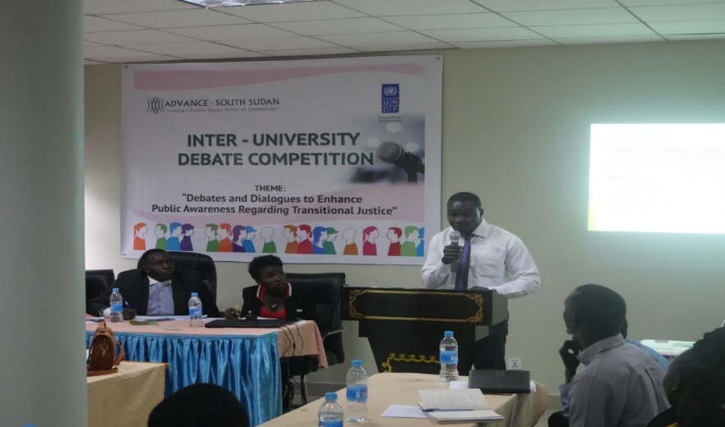
In line with Chapter V of the R-ARCSS which provides for transitional justice mechanisms, the project continues to disseminate information on the transitional justice mechanisms,.. A total of 52,172 persons were reached with transitional justice messages in Yei and Juba. In Yei, the project partnered with Advance South Sudan (ASS) - a CSO, to sensitize citizens to participate in transitional justice mechanisms. Advance South Sudan disseminated the message of transitional justice through inter-university debates, drama, radio talk shows and training of leaders including women and youth on transitional justice. The project also trained 27 (10 female) members of the CSOs to improve their knowledge on the contents of the six policy papers developed by UNDP to guide the formation of the Commission for Truth, Reconciliation and Healing (CTRH) and to strengthen their capacity in conducting awareness on transitional justice, especially on the CTRH legislation. The trained CSOs have raised awareness to 2,743 persons (1,491 female) in 11 locations: Maridi, Akorogbodi, Jonglei, Warrap, Kapoeta,. Torit, Western Balher Gazal, Northern Balher Gazal, Western Lakes State, Western Equatoria, and Yei.

As part of outreach on transitional justice processes: 1,115 (615 female) victims of past human rights abuses were sensitized on the composition and role of the CTRH and transitional justice across seven locations including Maridi, Akorogbodi, Joglei, Warrap and Kapoeta. Additinally, three CSOs reached 52,172 people, made them aware about transitional justice and ensured their voices inform the anticipated processes and mechanisms

2.3 Human Interest Story.

PCRCs establishment in Ifanyak, Torit.

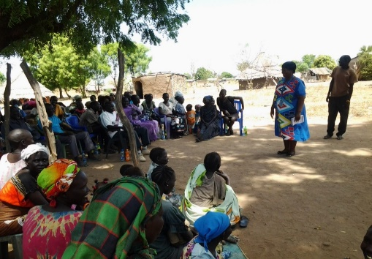  Figure 4: UNDPs Law Enforcement Advisor speaks to Ifanyak community members in April 2019 during the establishment of PCRCs. Photo: UNDP. | 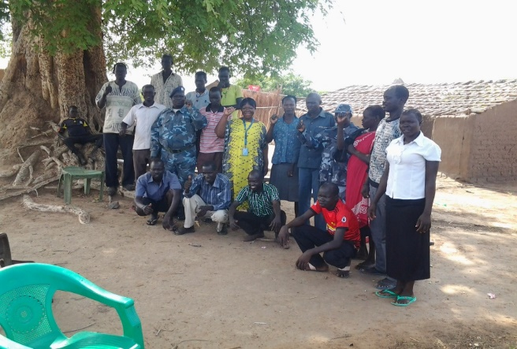  Figure 5: members of one of the newly established PCRCs in Ifanyak pose for a group photo. April 2019. Photo: UNDP.

The community members of Ifanyak, a Payam under Torit Municipal Council was living in fear as a result of increased criminality in the area. In the past few months incidents on house break-ins, theft, robbery and rape had increased. Other social problems including an increase in the crime rates, domestic violence, alcohol abuse, in fighting among community members were raised as issues of concern by the area Paramount Chief during the Rule of Law forum.

UNDP convened meetings with collaborating agencies, the police and the community members of Ifanyak. It was decided that PCRCs should be established in the 3 blocks of Ifanyak and community policing initiatives to follow. Community members organized themselves in groups and started patrolling the area during the day and night.

The outcome: Due to the cooporation and coordinated efforts by the Ifanyak community no incidents of insecurity have been reported ever since the community members started patrolling their neighborhoods. The members of the community have reported an increased sense of security as they carry out their daily activities as no criminal activities. has been reported for the last few months.

Cross Cutting Issues

3.1 Gender Results

Gender results | Evidence
Gender result 1: There is strengthened response to Sexual and Gender-based Violence (SGBV) as a result of the establishment of the first SGBV and Juvenile court in South Sudan, development of the training manual on the investigation and prosecution of SGBV cases and training 87 justice actors including judges, prosecutors, investigators and social workers. Twenty-one (21) justice actors have been deployed to the court and 200 GBV cases have been registered with hearing set to begin in February 2020. | Evidence 1: Reports from UNDP Rule of Law Officers.
Gender result 2: Increased access to legal aid services to survivors of SGVB through Special Protection Units (SPU) that continue to operate in Juba, Aweil, Torit, Bor, Wau, Yambio and Maridi. The SPUs provide a link to GBV survivors to legal aid providers (Civil Society Organizations).  The police and social workers stationed at the SPUs continue to receive trainings and mentorship on how to handle SGBV cases. In 2019, 129 (107 female) GBV cases were recorded and assisted through the SPUs. | Evidence 1: SPU reports, UNDP field staff reports, monitoring visits.

Partnerships

The project collaborated with various institutions, including the government and UN agencies. The partnerships have enabled improved delivery of results through the provision and maximization of unique expertise and competencies brought in by various institutions.
In working with government, the project’s technical staff work closely with ministries of Justice and Interior, and also the Judiciary to support the development of policy and legislation. The project also developed successful relationships with the SSNPS – for delivery of project activities involving the police service, and NPSSS – for delivery of project activities involving prisoner rehabilitation and capacity building of prison personnel.

In support of combined upstream and downstream activities, the project developed strategic partnerships with the national and state governments to enhance the development of policies and legislation, as well as improvement of service delivery that is responsve to community needs.

UNDP also partnered with UNMISS Human Rights Division, UNMISS-Rule of Law, United Nations Entity for Gender Equality and the Empowerment of Women (UN Women), United Nations Food and Agriculture Organization (FAO), United Nations Children’s Fund (UNICEF) and United Nations Population Fund (UNFPA) to foster complementarity and minimize duplication of activities.

In addition to this, UNDP partnered with 19 CSOs to provide transitional justice awareness, increase access to supportive services for GBV survivors, provide victim support, legal aid and strengthen community policing. By partnering with CSOs, UNDP strengthened their capacities for sustainability of project results and also increased civic engagement in the justice and security sector.

Environmental Considerations

The project’s procurement process included environmental sensitivity analysis in accordiance with UNDP’s Social and Environmental Standards were applied throughout project implementation to mainstream social and environmental sustainability.

Sustainability.
To ensure sustanabilty, the project works with existing statutory institutions by building their capacity to deliver required services beyond the project implementation. To this end, the project supports the development of systems and processes in the existing rule of law institution and provides working tools and equipment. The project also stimulates demand for justice and rule of law services by working with individuals to increase their awareness regarding their rights and accessing justice institutions.

South to South and Triangular Cooperation (max 1/2 page)

No South to South and Triangular Cooperation has been undertaken in 2019.

Strengthening National Capacity
Results achieved | Institution | National capacity strengthened
- Improved response to security challenges through infrastructure renovation and construction. | SSNPS | In support of infrastructural development, police facilities were renovated (3) and construction upgrades done including office blocks, training academy and toilets. 1,103 (258 female) police officers had their capacities improved through training mentoring.
- Improved understanding on human and women’s rights. | Traditional leaders | 249(69 female) traditional leaders trained on principles of human rights, law, and women’s rights.
- Improved capacity of justice institutions to increase access to justice. | Judiciary of South Sudan, | The first GBV and Juvenile court was established and operationalized in Juba, 87 justice actors including judges, prosecutors, investigators and social workers were trained on how to handle GBV cases. In addition to this a training manual on the investigation and prosecution of SGBV cases was developed.  Dispatching five mobile courts to remote locations and locations that have no judges.
- Improved capacity of CSOs raise awareness on Transitional Justice and the Commission for Truth Reconciliation and healing | CSOs | UNDPP trained 27 (10 female) members of the CSOs to improve their knowledge on the contents of the six policy papers developed by UNDP to guide the formation of the Commission for Truth, Reconciliation and Healing (CTRH) and to strengthen their capacity in conducting awareness on transitional justice especially on the CTRH legislation.

Monitoring and evaluation

Key M&E activities conducted during the quarter:
Key M&E activity | Key outcomes/ observation | Recommendation | Action taken
M&E activity  Monitoring visits to project sites in Bor and Aweil. | - The Rule of law forum is proving to be an effective platform for different actors to meet and address issues.  - Support the Special Protection Units (SPU) needs to be scaled up to provide basic needs for the survivors and for the SPU officers to be trained to be able to offer better psycho-social support to the SGBV survivors through communication and operational support  - The traditional leaders need to be supported with basic provisions including stationary, to enable them to keep records of the cases they preside over. | During the development of the next phase of the project, these needs/ requests need to be factored in as part of the project’s interventions. | The needs have been captured and will be used to inform the next phase.
Collection of reporting data from CSO is challenging. | - Some CSOs do not have a field office in locations they are implementing making it difficult to monitor them.  - Issues with delivery of timely reports from CSOs  - Some CSOs do not provide good quality reports in terms of content.  - Short implementation period making it difficult to measure impact of CSOs efforts. | - The Field officers should be engaged in the CSO selection process as they know which CSOs have a field presence.  - Train the CSOs  - Consider having long term engagements with performing CSOs. | The project team will have a meeting to address this issues.
On-site monitoring for the completed constructions of VTC center in Wau and prison facilities in Terekeka and Juba, | Activities were completed per the technical specification and project progress was reported to be on track. | The project engineer continues to monitor all renovation and construction activities. | The project engineer continues with close monitoring visits.
Final Evaluation | Finding 1. Overall, the project achieved its intended results and contributed towards planned country programme outcomes. Most of the project’s planned targets were achieved, particularly with regards to upstream work for development of policies and legislation; although some of the outputs were not followed through due to weak government capacity or political will to implement them - for example, the Legal Aid Bill has not been enacted into law.  Finding 2: Government capacity is weak, especially in the states. Ultimately justice and rule of law have to be delivered through state institutions. Presently, the government has not demonstrated capacity to fulfill this role. The shortage of judges and prosecutors across the judiciary is more a function of poor conditions of service than anything else. Organisational capacity such as budgets for running costs for all sector ministries is at its lowest. The police have to rely on ‘handouts’ of paper stationery from UNMISS, who in Aweil for example, ration them to five per day. Even in the traditional courts, only the Paramount Chief receives a monthly salary of 1,000 South Sudanese Pounds (which is less than US$50); yet the Local Government Act provides that Head Chiefs of the ‘B’ Courts should sit as members of the ‘C’ Court which is chaired by the Paramount Chief.  Finding 3. Although the project did not address underlying causes for the lack of rule of law, it addresses the critical need for justice for disadvantaged and vulnerable groups. The project was not designed to address the fundamental governance challenges facing the country, which are the underlying causes for the lack of rule of law and weak justice delivery system in the country. Some of these challenges for example, include the resolution of political differences and enforcement of the peace agreement by the two major political parties. These are issues that are handled at the highest level within the UN system, including in the UNCT and the Security Council. At the same time however, there is that woman or girl in the remote areas of the country who has been sexually abused. She needs counselling, medical attention and justice in order to achieve closure and move on with her life. This is where the project has provided the most value added. | The overall evaluators’ recommendation to UNDP and donors is to continue the project and develop the successor phase 3 when the current phase ends in March 2020. The project is addressing a critical gap, especially for the most vulnerable and disadvantaged groups, who otherwise would have no hope of enjoying their basic rights under the ‘rule of law’.  Recommendation 2. UNDP should review its capacity-building approach to make it more responsive to the conditions in the country. South Sudan has very low human capital. Some reports noted that at the time of its independence in 2011, less than 2 percent of the population had any high school education. In such an environment, there is need to do an initial capacity needs assessment, followed by capacity evaluation to determine whether, and to what extend the capacity development is achieving intended results.  Recommendation: UNDP must change its business model and adopt more of integrated programming. The rule of law cannot exit in isolation, and can only flourish when certain enabling conditions are available. For ‘rule of law’ to flourish, there are necessary conditions that must prevail as enabling factors, including a functional, independent and impartial judiciary; free legal aid for those who cannot afford; and availability of social and economic facilities for citizens to enjoy and protect. UNDP should ensure that its programming addresses these essential conditions through integrated programming across relevant thematic areas and projects. | The project has been engaging the donors to support the next phase of the project.  Way Forward: The program plans to conduct a capacity needs assessment of all the core justice and security institutions to better understand their needs so that in the next phase of support, interventions are tailored to those needs. The data generated will further be used to inform national and state level rule of law decision-making as well as reviewing UNDP’s capacity-building approach to be more responsive to the conditions in the country.  Way Forward: For the new phase of the program, UNDP will respond to the immediate human rights, justice and security needs of communities and individuals in a way that complements on-going projects by UNDP to strengthen livelihoods, local governance and social cohesion in these same communities. E.g., survivors of SGBV in Yambio who are supported through the program to access legal redress, will also be connected to the livelihoods project in the same state to benefit from the skills training through the Vocation Training Centres as this will achieve greater impact in breaking the cycle of violence against women and girls.

The Project Finance Specialist continues to provide fiduciary oversight over the 19 CSOs benefiting from grants. The Chief Technical Advisor, Law Enforcement Advisers and Rule of Law Officers shared lessons and good practices in different forums with development partners and HQ/UN/donor mission members during the reporting period.

Risk Management

Risks | Mitigation Measures
Continued political polarization and uncertainty around the peace agreement undermine commitments to the rule of law. | The project works with lower, middle, and leadership officials in partner institutions to increase the likelihood that interventions will withstand political mutations. The project provides donors with relevant information regarding the operating environment and this has resulted in increased support to the rule of law sector, especially on community-level interventions. The project also focuses on community-level interventions as they are less prone to political influences.
An unstable security situation limits access for implementation of activities. | The project partners with Civil Society Organizations to implement in such locations. This is because the CSOs are national organizations and as such have a greater reach and are not prone to be targets of insecurity incidences.

Challenges

The challenges identified this quarter are as follows:
- Limited trust between the Government agencies and CSOs working in human right sector: The relationship between the Government and CSOs working in thehuman rights sector tends to be tense. Government agencies continue to monitor CSOs' project activities, especially on the rule of law and human rights-related activities. UNDP is working to mitigate the tension and foster trust among all actors across the justice and rule of law sector and improve their collaboration. During regular coordination meetings, specific incidents are raised to the attention of the authorities. UNDP advocates for respect for constitutional public liberties, including freedom of speech and association, while also advising partner CSOs to be conflict sensitive in their messages.
- The effects of the conflict have created a complex situation with high unmet justice and security needs among the vulnerable groups. This over-stretches the capacity of UNDP and its partners to implement project activities. The densely populated Protection of Civilians sites and the new wave of returnees from Sudan to Bentiu state has created an immense pressure on national partners to deliver on law enforcement activities within and outside the Protection of Civilians in various states. The project responded to this by intensifying resource mobilization to diversify its donor base to meet the mounting demands.
- Limited human and material capacity of rule of law institutions continues to impact the quality of services provided by Government. Low levels of skills amongst partners and budgetary constraints of partner institutions impact the extent to which partners can deliver on their specific mandates. The project continues to provide technical support and, on-the-job training, mentoring to police and prison personnel and has provided equipment for use by police and prison’s services. Lack of state resources to public institutions does not allow for expansion of the Justice infrastructure and personnel to other states thus resulting in their dependence on international assistance, which is not always sustainable.
- Inadequate coordination in the rule of law sector due to frequent change of leadership and staff of rule of law institutions. The project relied on the project board, rule of law forums and a rule of law working group among others to coordinate the activities of national rule of law institutions and attain cohesion among development partners.

- Lessons Learned:

Lessons learned:
- Partnerships with local CSOs stimulate the demand for effective justice delivery. A focus on capacity building of community-based organizations empowers people/organizations within their communities to respond to legal issues and engage with justice and related administrative systems more effectively.

- Implemented strategies should be revisited periodically to review efficiency and compatibility with international standards. The mobile court system, for example, requires laying down additional measures to ensure sustainability and national ownership. Furthermore, its effectiveness, responsiveness and respect to international human rights and fair standards should be ensured through constant monitoring.

- It is important to recognize that rule of law sector capacity development is a long-term endeavour requiring a sector-wide approach in project implementation. Partnerships at the local, state and national levels are crucial to contribute to improved access to justice. This has informed UNDP’s approach in the Access to Justice and Rule of Law project.

- Importance of collaborating with UN agencies: Many opportunities were presented for UNDP to collaborate with other UN agencies. In this regard the project forged partnerships with UNFPA and UNICEF in conducing SGBV and community policing training. This collaboration reduced the cost of activity implementation and created sustainable mechanisms for collaborative training.

- Importance of continued engagement with national counterparts including the MoJCA, JoSS, Police and prisons: Continued engagement with national stakeholders facilitated the convening of forums and stimulated dialogue on sensitive political, rule of law, and peace and reconciliation issues, such as transitional justice, the R-ARCSS peace agreement, SGBV and other protection issues.

- Conclusions and Way Forward.
The project had a final evaluation as the current phase of the project will be ending in March 2020. The findings of the evaluation were positive and recommended that the project should continue implementing as it remained relevant in the context of the country. In this regard, the project has been engaging the donors to support the next phase of the project. The program plans to conduct a capacity needs assessment of all the core justice and security institutions to better understand their needs so that in the next phase of support, interventions are tailored to those needs. The data generated will further be used to inform national and state level rule of law decision-making as well as reviewing UNDP’s capacity-building approach to be more responsive to the conditions in the country.
For the new phase of the program, UNDP will respond to the immediate human rights, justice and security needs of communities and individuals in a way that complements on-going projects by UNDP to strengthen livelihoods, local governance and social cohesion in these same communities. E.g., survivors of SGBV in Yambio who are supported through the program to access legal redress, will also be connected to the livelihoods project in the same state to benefit from the skills training through the Vocation Training Centres as this will achieve greater impact in breaking the cycle of violence against women and girls.

Financial Summary

Outputs / Activity Result |  | Current Annual Budget, US$ (Jan – Dec 2019) | Expenditures (Jan - September 2019) | Expenditures (Oct - Dec 2019) | Cumulative Expenditures (Jan - Dec 2019) | % Expenditure (Cumulative)
 |  | A | B | C | D=B+C | D/A*100
Output 1: Functions and capacity of rule of law institutions enabled to deliver accountable, effective and equitable justice services.
AR 1.1 | Capacity of rule of law institutions to draft and review key legislation improved, with particular attention to human and women’s rights. | 1,396,506.91 | 1,136,244.04 | 238,153.79 | 1,374,397.83 | 98.42%
AR 1.2 | Mobile court established to reduce case backlog and arbitrary detention. | 231,459.88 | 117,808.85 | 73,358.44 | 191,167.29 | 82.59%
AR 1.3 | National prisons service empowered to care and rehabilitate inmates in line with international standards. | 1,212,386.47 | 327,410.85 | 806,914.32 | 1,134,325.17 | 93.56%
AR 1.4 | Unified case management system established through coordination between rule of law institutions for timely processing of cases and reduction of case backlog. | 219,783.41 | 182,188.04 | 30,606.05 | 212,794.09 | 96.82%
AR 1.5 | Consistent application of human rights standards by customary leaders facilitated. | 234,565.45 | 108,532.90 | 78,214.62 | 186,747.52 | 79.61%
AR 1.6 | Providing technical and financial support to the Ministry of Gender for the establishment of Child Marriage Taskforce | 0.00 | 0.00 | 0.00 | 0.00
AR 1.7 | Facilitating the provision of defense representation, litigation on constitutional rights and awareness on child marriage. | 58,179.23 | 53,279.03 | 137.16 | 53,416.19 | 91.81%
AR 1.8 | Undertaking media and public outreach campaigns on End of Child Marriage’ programme. | 9,000.00 | 8,569.75 | 0.00 | 8,569.75 | 95.22%
AR 1.9 | SURGE | 100,000.00 | 0.00 | 0.00 | 0.00 | 0.00%
AR 1.10 | UN ACTION against seual violence in conflict in South sudan | 656,808.00 | 17,173.40 | 435,827.73 | 453,001.13 | 68.97%
Output 1 Sub-total |  | 4,118,689.35 | 1,951,206.86 | 1,663,212.11 | 3,614,418.97 | 87.76%
Output 2: Measures in place and implemented in the rule of law sector to prevent and respond to sexual and gender-based violence.
AR 2.1 | Legal aid providers empowered to deliver legal services to vulnerable population groups, including SGBV survivors. | 357,575.88 | 224,283.67 | 46,483.13 | 270,766.80 | 75.72%
AR 2.2 | Strengthened referral paths for vulnerable people to increase protection and opportunities for legal redress. | 1,126,716.15 | 810,635.73 | 308,950.65 | 1,119,586.38 | 99.37%
AR 2.3 | Create an enabling environment for safe and dignified returns through deployment of a professional police force (including the Joint Integrated Police). | 192,228.85 | 110,716.15 | 58,058.00 | 168,774.15 | 87.80%
Output 2 Sub-total |  | 1,676,520.88 | 1,145,635.55 | 413,491.78 | 1,559,127.33 | 93.00%
Output 3: Human rights and transitional justice mechanisms strengthened to monitor and respond to the promotion and protection of citizen's rights.
AR 3.1 | Strengthen mechanisms for oversight and monitoring of the promotion and protection of human rights in South Sudan. | 0.00 | 0.00 | 0.00 | 0.00 | 0.00%
AR 3.2 | Support the establishment of transitional justice, peace and reconciliation mechanisms in accordance with Peace Agreement and informed by international standards. | 116,572.48 | 31,274.42 | 31,437.91 | 62,712.33 | 53.80%
AR 3.3 | Project management support | 1,303,532.79 | 1,076,918 | 190,481 | 1,267,398.41 | 97.23%
Output 3 Sub-total |  | 1,420,105.27 | 1,108,192.04 | 221,918.70 | 1,330,110.74 | 93.66%
Output 4: Emergency Support for Women and Vulnerable Groups through Improved Law Enforcement Capacity, including Joint Integrated Police (JSB 2017)
AR 4.1 | Improved professional capacity of transitional security arrangements (including the JIP) | 5,000.00 | 535.86 | 2,304.14 | 2,840.00 | 56.80%
AR 4.2 | Improved local-level security and increased public trust in law enforcement through community policing initiatives | 41,411.00 | 27,875.06 | 10,574.20 | 38,449.26 | 92.85%
AR 4.3 | Increased accessibility and improved rapid response capacity of police through Emergency Call Centres | 23,517.91 | 18,956.02 | 0.00 | 18,956.02 | 80.60%
AR 4.4 | Project management | 1,942.00 | 0 | 1,314 | 1,314.36 | 67.68%
Output 4 Sub-total |  | 71,870.91 | 47,366.94 | 14,192.70 | 61,559.64 | 85.65%
Output 5: JSB 2018 (Japan)
AR 5.1 | Supporting professionalisation of the police force | 70,000.00 | 0.00 | 32,890.82 | 32,890.82 | 46.99%
AR 5.2 | Supporting community policing initiatives or improved local-level security and increased public trust in law enforcement | 124,600.00 | 32,169.25 | 46,064.27 | 78,233.52 | 62.79%
AR 5.3 | Support operationalization of the Juba and Wau ECC | 220,000.00 | 0.00 | 110,071.60 | 110,071.60 | 50.03%
AR 5.4 | Support to project management | 41,400.00 | 0 | 42,887 | 42,886.90 | 103.59%
Output 5 Sub-total |  | 456,000.00 | 32,169.25 | 231,913.59 | 264,082.84 | 57.91%
Grand total |  | 7,743,186.41 | 4,284,570.64 | 2,544,728.88 | 6,829,299.52 | 88.20%

https://www.hrw.org/world-report/2018/country-chapters/south-sudan
https://thoughtsonthesudans.files.wordpress.com/2018/02/18-02-14-chapter-1
https://www.southsudanhealth.info/PublicData/Library/Policy_Documents/South%20Sudan%20Vision%202040.pdf
www.undp.org/content/dam/undp/library/corporate/.../2017/.../DP2017-38.docx
https://ss.one.un.org/united-nations-cooperation-framework-for-the-republic-of-south-sudan.html
https://digitallibrary.un.org/record/1637541
Partially achieved means the achievement of 66%-99% of the output target
Indicator in project document says “proportion” but targets are in absolute numbers. The indicator has thus been changed to be in line with targets.
Number of PCRC meeting held
Number of Community policing initiatives adopted
https://www.ss.undp.org/content/south_sudan/en/home/presscenter/articles/2019/high-level-officials-from-the-netherlands-and-head-of-undps-cris.html
Local Government Act, Section 99, sub-section 4 (a) and (b) – p49

